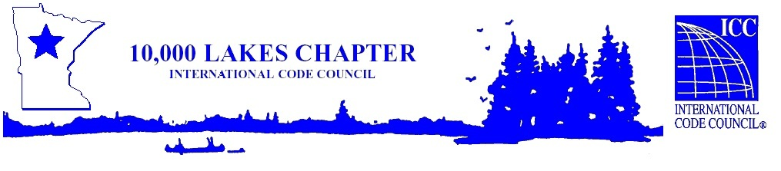

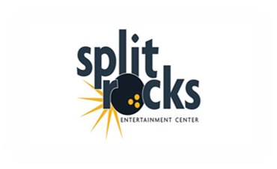



As a valued member of the 10,000 Lakes Chapter, you and one companion are invited to join us for the 10K Holiday Party at Splitrocks Entertainment Center!

**Saturday December 7th, 2024 Afternoon event! 1:00pm – 5:00pm**

Enjoy food and beverages, generously provided by the 10,000 Lakes Chapter.

After dinner, join us for an exciting Casino Night, featuring fantastic prizes available for auction!

Due to the planning requirements of this particular space, we need accurate RSVP’s from attendees, **please include your name and companion name by December 2nd!**

**RSVP no later than December 2nd by emailing:**

**dschilling@wspmn.gov**

Please plan appropriately and let us know if you will be attending this event.

We are unable to take RSVPs at the door.

If you have questions, contact:

dschilling@wspmn.gov or (651)-522-4135

Looking forward to seeing you there!

Dennis Schilling

10,000 Lakes President for 2024