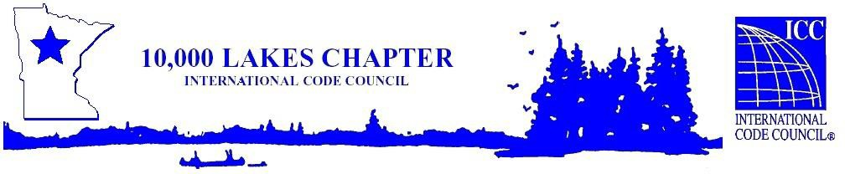

10,000 Lakes Chapter Business Meeting

West St Paul City Hall

Thursday, January 9th, 2025 @ 9:00 am – 10:30 am

1. **Call to Order:**

**AGENDA**

1. **Roll Call of Officers:**

Isaac Stensland – President Greg Brady - Director

Travis Dunn – Vice President Colby Cartney - Director

Steve Kartak – Secretary John Caldwell - Director

Arlen Madsen – Treasurer Caleb Hansen - Director

Dennis Schilling – Past President ScottAndersonDirector Philip Marvets Director Nate Borwege Director

1. **Introductions of Attendees:**
2. **Swearing in of the 2025 Board of Directors by ICC’s Rick Hauffe.**
3. **Approval of Business Meeting Minutes from October 10, 2024.**
4. **Treasurer’s Report (Arlen Madsen)**
5. **Contractor Spring Training Update: Date TBD at Huikko’s Bowling Center, Buffalo, MN**
6. **State Code Division Report: DLI, Code Services Representative**
7. **Chapter Updates & 2025 Planning**
   * Reminder for jurisdictions that 10K lakes renewal of membership for 2025 is now available for sign up on the 10K website.
   * 10K Spring Seminar: April TBD
   * 10K Roadside Clean up: May 21st, 2025 4:30pm

Latter Day Saints parking lot

11900 Manning Ave.  
Hastings

* + 10K Summer Conference: June 16th – 18th @ Sugar Lake Lodge

1. **Code Roundtable & General Discussion:**
2. **Announcements:**
   * Next Chapter Meeting – March 13th, 2025 @ 9am Location – West Lakeland Township Office Hall 959 Paris Avenue Circle, Stillwater, MN 55082
   * Next Board Meeting – February 13th, 2025 @ 9am - Location – Machine Shed 8515 Hudson Blvd. Lake Elmo, MN 55042
   * Jobs
     + Robbinsdale - Building Official
     + Chaska - Building Inspector
     + Crystal – Building & Housing Inspector
     + Chanhassen – Mechanical/Plumbing inspector
     + Moorhead – Code Compliance Technician
3. **Adjourn:**