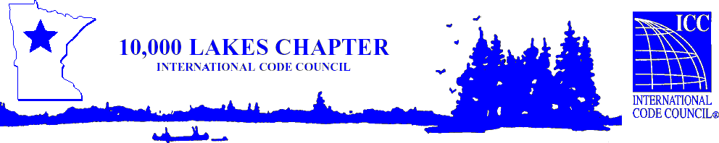

# **10,000 Lakes Chapter of ICC**

**2024 IBC Transition from the 2018 IBC**

**June 17, 2025**

Presented by ICC Instructor Doug Thornburg

***Learning Objective***

**2024 IBC Transition from the 2018 IBC. This seminar will assist participants in implementing the transition from the 2018 to the 2024 International Building Code. It will include relevant changes that occurred in both the 2021 and 2024 editions. Although most of the presentation focuses on revisions to the IBC fire- and life-safety provisions, additional areas of discussion include accessibility, construction materials and building services.**

Cost is $150 seminar & conference or $130 seminar only for 10K Lakes **members.**

Cost is $170 seminar and conference or $150 seminar only for **non-members**.

MN DLI awards 6 C.E.U.’s & ICC awards 0.6 C.E.U.’s per full day of attendance.

Pending Approval by the **MN Department of Labor and Industry**

# **Location: Sugar Lake Lodge**

**37584 Otis Lane**

**Cohasset, MN 55721**

10,000 Lakes One Day Chapter Education Vouchers Are Accepted for This Seminar

Please register online @ <https://10klakes.org/events/>

Sign-in begins at 7:00 AM - Seminar begins at 7:30 AM till 2:30 PM with two 15min. breaks and a one-hour lunch. Morning beverages, snack and lunch will be provided.

For further information or refund info contact Travis Dunn at **travis@dunn-solutions.com**