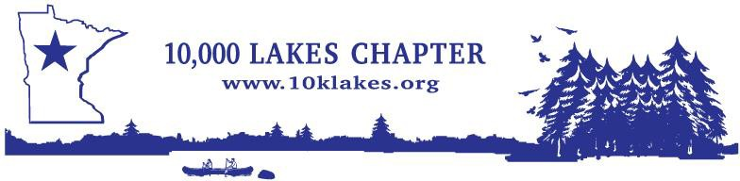 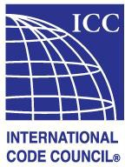

Sugar Lake Lodge Welcomes

**10,000 Lakes Chapter of ICC Summer Conference**

June 15th- 18th, 2025

Please call (218)-327-1462 to make lodging reservations to ensure availability and to receive the special conference rates.

10,000 Lakes has reserved a variety of lodging types:

Nightly Rate Unit Description

$189 Studio Villa - Located along the golf course. 1 King or 2 Twin beds, small refrigerator, microwave & coffee maker.

$199 Lodge Studio - Located in the main lodge. 1 King or 2 twin beds, small refrigerator, microwave, coffee maker, fireplace & jetted bathtub.

|  |  |
| --- | --- |
| $349 | Lodge Suite - Located in the main lodge. Full kitchen, living room with fireplace. |
| $319 | Two Bedroom Villa - Located along the golf course. Full kitchen, living room with fireplace. |
| $329 | Lakeside Cabin - Tucked right along the shoreline of Sugar Lake. Each cabin features a knotty |

Cabins also include a small refrigerator, microwave, coffee maker and full bathroom.

*Room types are subject to availability. Lodging rates are subject to tax.*

**Sugar Lake Lodge rooms are filling up fast, so book your rooms soon!**

Please call (218)-327-1462 for lodging reservations & cancellation policy.

Sugar Lake Lodge

37584 Otis Ln, Cohasset MN 55721