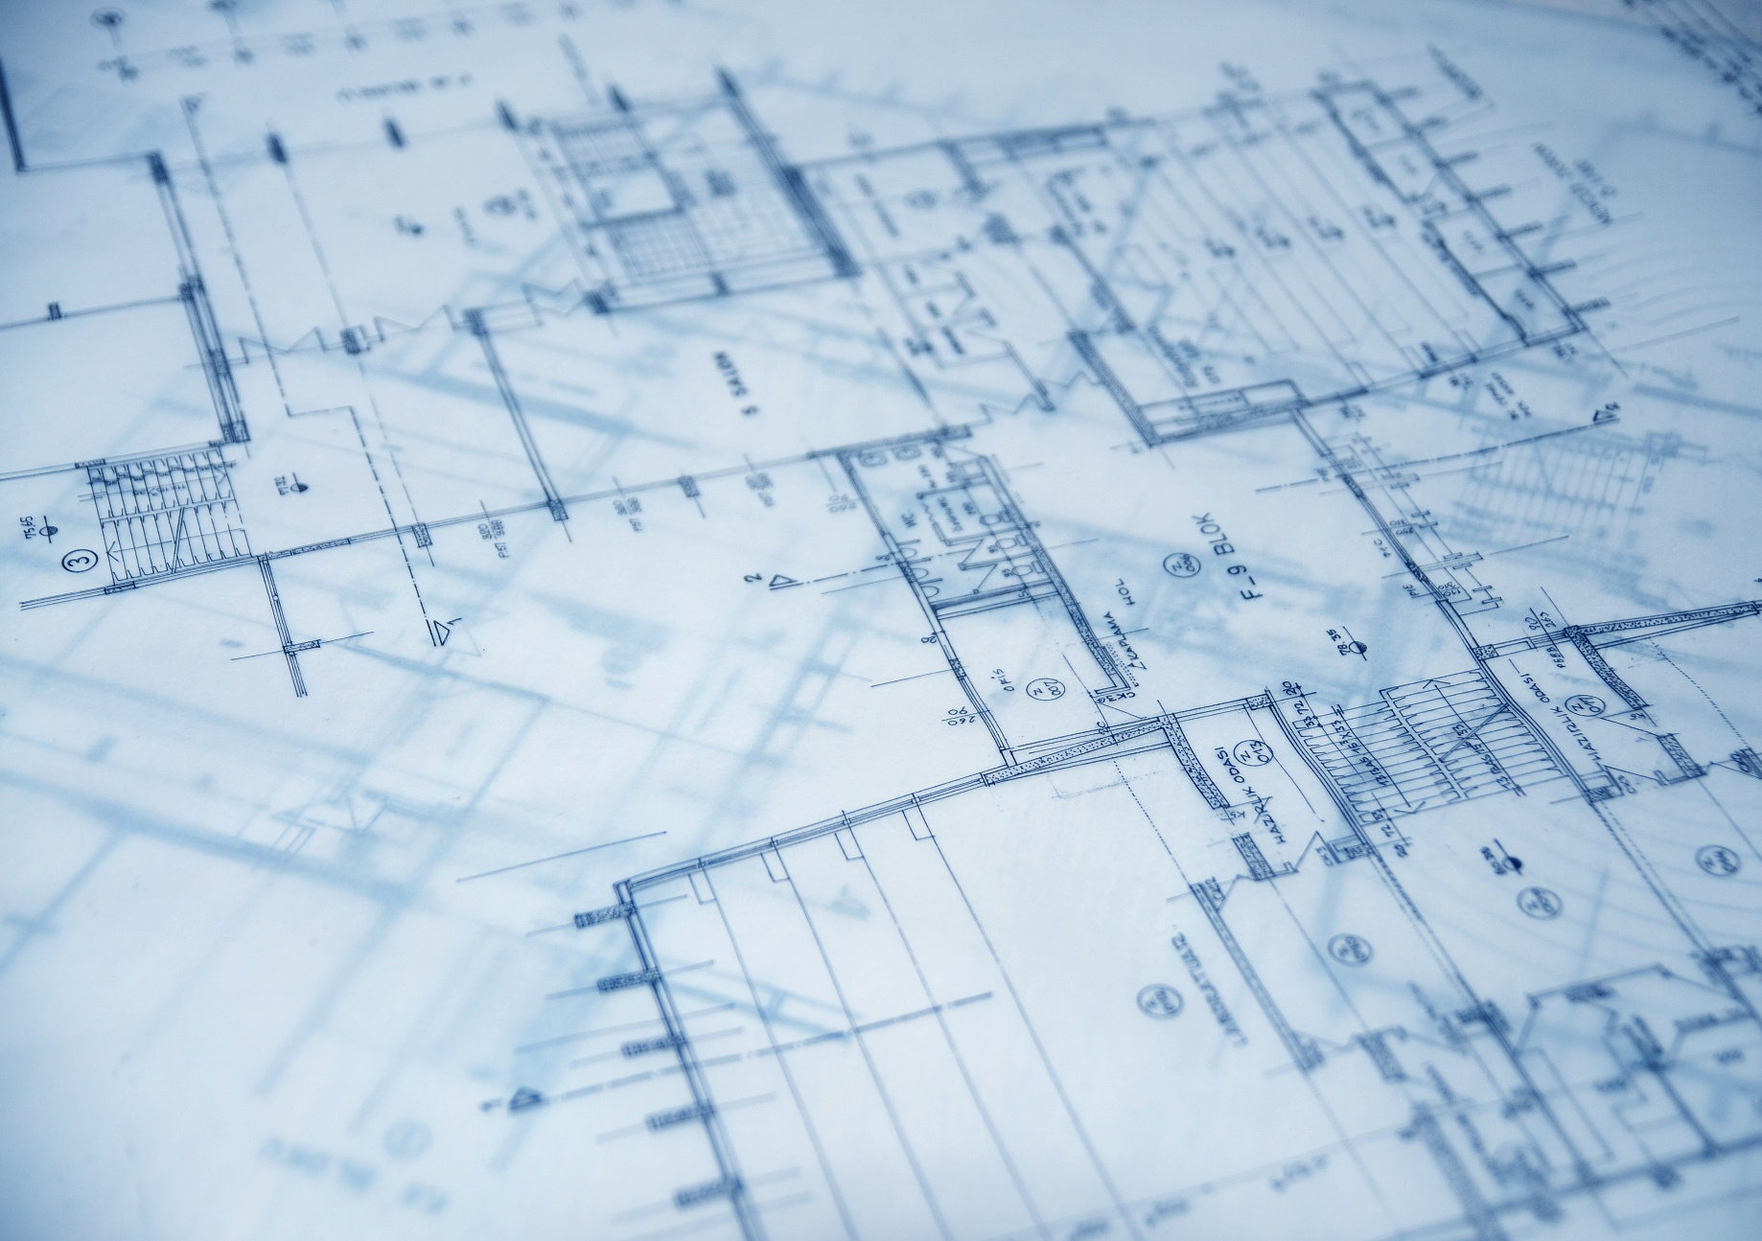

**Regular Pricing (after 12.15.2025)**

**10k Members: $225.00**

**Non-Members: $250.00**

**Early Bird Pricing (before 12.15.2025)**

**10k Members: $200.00**

**Non-Members: $225.00**

**Continue your education and get up-to-date information on Minnesota code rules and amendments, best practices for inspection and code administration, innovative products on the market, and useful professional development skills at the first annual 10k Annual Institute.**

**More details to come:** [***www.10klakes.org***](https://10klakes.org/)

**PLYMOUTH COMMUNITY CENTER**

**14800 34TH AVE N, PLYMOUTH, MN 55447**

**10K Annual Institute**

**(formerly AIBO)**

**SAVE THE DATE**

**JANUARY 12-16, 2026**