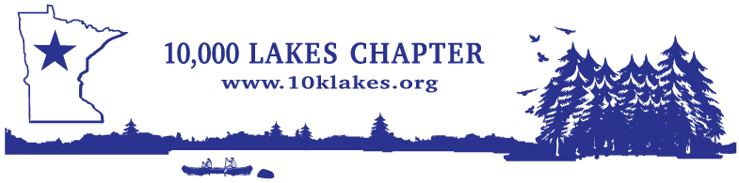

10K Lakes Chapter
Summer Education Conference

July 22nd-24th, 2026
Craguns Resort

Events and Activities Signup Sheet
Please fill out and email the following portion and email to: travis@dunn-solutions.com
This is for planning purposes only so we can provide more accurate figures for Golfing and Meals/Beverages Meals are provided for the attendee Thursday and Friday

Which Activities will you be participating in? | Attendee |  | Companion |  | # of Guests
*** Golf Tournament ***  Wednesday, July 22nd  12:15-12:55 (10 Min Intervals)  Lehman 18  Rate: $139 plus tax per player  Includes: 18 holes, GPS cart and range balls. | Yes | No | Yes | No
Companion joining Attendee for lunch Thursday July 23rd |  |  | Yes | No
Companion joining Attendee for dinner Thursday July 23rd |  |  | Yes | No
Wine Tasting Thursday July 23rd 1pm Level 2 by WSET |  |  | Yes | No
Pontoon Ride Thursday July 23rd 1-4pm (Captain will be down by the docks) | Yes | No | Yes | No
Companion joining Attendee for Breakfast Buffet Friday July 24th |  |  | Yes | No
Hospitality Suite for Drinks and Snacks July 22nd and 23rd in Presidential Suite 2 | Yes | No | Yes | No
*** Golf tournament payment will be made in the golf clubhouse day of the event ***
The Resort will provide a shuttle to and from the clubhouse if needed
* Spouse or Children are welcome to attend, please select meals when signing up per the activities sheet attached, Cost $20 per person for the meal. Please submit this activities sheet to travis@dunn-solutions.com and drop off Cash or Check to the Hospitality Room on July 22*

