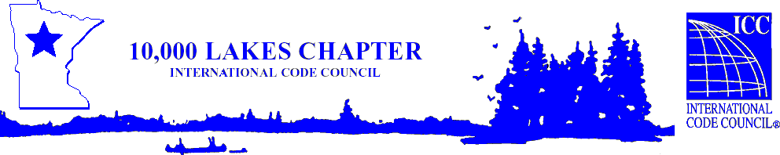
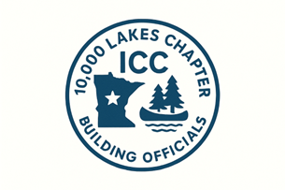

10,000 Lakes Chapter of ICC
2024 IRC Transition from the 2018 IRC
July 23, 2026
Presented by ICC Instructor Richard Truitt

Learning Objective
2024 IRC Transition from the 2018 IRC. This seminar will assist participants in implementing the transition from the 2018 to the 2024 International Residential Code. It will include relevant changes that occurred in both the 2021 and 2024 editions.

Cost is $200 seminar & conference or $180 seminar only for 10K Lakes members.
Cost is $220 seminar and conference or $200 seminar only for non-members.
MN DLI awards 6 C.E.U.’s & ICC awards 0.6 C.E.U.’s per full day of attendance.
Pending Approval by the MN Department of Labor and Industry

Location: Craguns

11000 Craguns Dr.
Brainerd, MN 56401

10,000 Lakes One Day Chapter Education Vouchers Are Accepted for This Seminar

Please register online @ https://10klakes.org/events/
Sign-in begins at 7:00 AM - Seminar begins at 7:30 AM till 2:30 PM with two 15min. breaks and a one-hour lunch. Morning beverages, snack and lunch will be provided.
For further information or refund info contact Travis Dunn at travis@dunn-solutions.com

