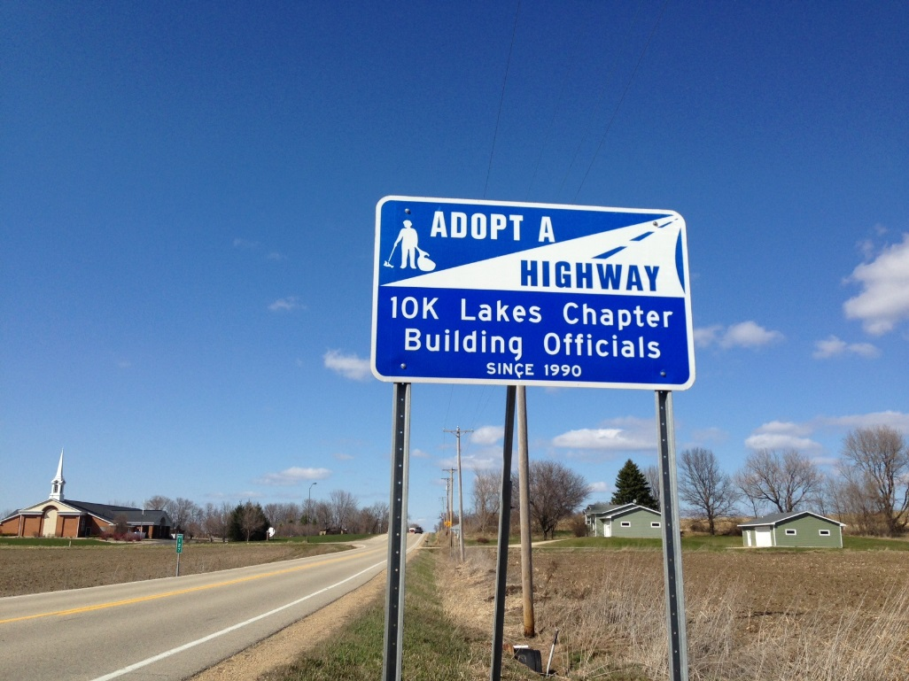
Mark your Calendar

The 2026 Fall Roadside Cleanup is approaching! Please join us for this important community service that will take place on:

Thursday October 1st at 1:30 pm. We gather at the Latter Day Saints parking lot located at 11900 Manning Ave. South just 0.25 miles north of Highway 61.

This is also a great opportunity to get to know and network with other code officials. See you there!

Your 10K Lakes Chapter of ICC Board of Directors

